Jon Hay, Kate Davis, Nick Pierce

We still don’t know what we’re doing for the actual content of our web apps, but we’re already discussing some of the differences and similarities in modern web frameworks and languages. Most of us have at least hello world running and are able to make get and post requests, which are the two core aspects of a web server.

Jon’s Website

Django and sql. Front end written in html, css, JS

Kate’s Website

Flask And MySQL. Front end HTML, CSS, Python

I have a basic web server running from Pythonanywhere, We don’t know what our web app is yet so I just have the basic route, to the main page. Which outputs “Hello WORLD!” . I would like to add several html pages, and set them up to route to each other. I will be embedding python into my html code as well.

CODE:

# A very simple Flask Hello World ap

from flask import Flask

app = Flask(__name__)

@app.route('/')

def hello_world():

return 'Hello WORLD!

Link: http://kadadavi.pythonanywhere.com

Include some code screenshots b

Nick’s Website

Using boostrap/jquery, js, and css for front end nodejs and sqlite3 for backend

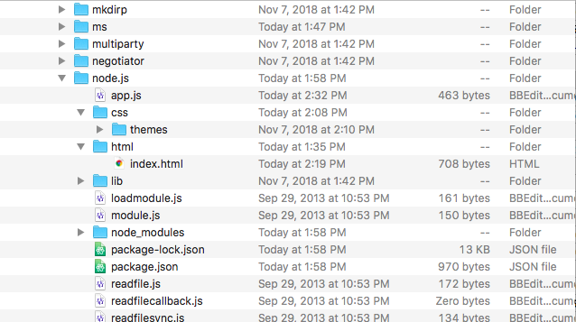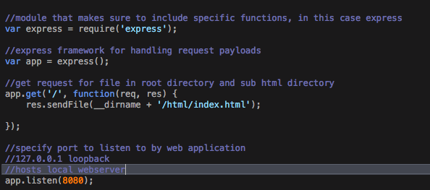

I’ve managed to basically get “hello world” running in node.js, create a file structure for a node project, as well as learn about npm package managing and version updates. It actually took me quite a long time to figure out how to even do a simple get request in node, I decided to use express as my web server framework. It handles all get and post requests we make. I started also reviewing how to use sqlite3 in order to familiarize myself with database structures for when we do actually decide our project idea. I also remade a new jquery theme incase I wanted to use jquery/jquery mobile for my site.